Native Americans and Diabetes
(Lesson 16)
Solution Key and Teacher’s Guide

STATEMENT OF THE PROBLEM
For a specific geographical area in the United States, is the age-adjusted rate of prevalence of diabetes in Native Americans higher than that of their non-Hispanic white counterparts?

*NOTE*
This problem requires students to find data from two counties in the United States that satisfy specific criteria. One county must have a high percentage of Native American residents, while the other county must have a high percentage of non-Hispanic white residents. At the same time, these counties must be located close to each other geographically. There may be many possible combinations of data sets that work, and the data most likely will change from year to year. For these reasons it would be impossible to have a solution key that supplies every possible answer. This teacher’s guide uses two counties in South Dakota for the solution key, Shannon County and Custer County. The counties are actually adjacent to each other. At the end of the solution key, two additional examples (Menominee County and Langlade County in Wisconsin, and Bethel Census Area and Denali Borough in Alaska) are included. These last two examples will include the data and other pertinent information, but not the full solution key like the first example. Answers and justifications, however, should be similar. Also included at the end, there is a map of each of the states that were used as examples. The maps show where the counties are located.

The population and ethnic data was gathered from the U.S. Census Bureau’s website, while the diabetes data was found on the Centers for Disease Control and Prevention’s website. Both sets of data are from the year 2010.

County in South Dakota → | Shannon County (2010) | Custer County (2010)
Targeted Ethnicity Population | 13,036 (Native American) | 7737 (White)
Total Population | 13,586 ( | 8216 (
Ethnicity Percent (approx.) | 96% Native American | 94% White
Diagnosed Diabetes Age-Adjusted Percentage | 19.5% () | 7.0% ()
Number of Successes  () (approx.) | 2649 ( | 575 (

Discussion and Questions:

1. Write the null and the alternative hypotheses.

SOLUTION: The null (and alternative ( hypotheses are as follows: *Some may prefer to use for alternative hypothesis.

(claim)

In this problem, represents the age-adjusted proportion of Native Americans diagnosed with diabetes while represents the age-adjusted proportion of non-Hispanic whites diagnosed with diabetes. The claim being made is that the age-adjusted proportion of Native Americans diagnosed with diabetes is higher than the age-adjusted proportion of non-Hispanic whites diagnosed with diabetes.

2. Briefly describe the consequences of α and β errors.

SOLUTION: An α (or type I) error would occur if the null hypothesis is true but it is rejected. In this case, that would mean the age-adjusted proportion of Native Americans diagnosed with diabetes is less than or equal to the age-adjusted proportion of non-Hispanic whites diagnosed with diabetes, but that hypothesis is rejected and, as a result, the claim is supported. Consequences of this error include suggesting an epidemic when there isn’t really one. This might lead to instilling unnecessary fear into the Native American population, and convincing many Native Americans to participate in unwanted programs, screenings, and testing. This could end up being very expensive and time-consuming for both the Native American population and the medical community. Ultimately, however, further testing should eventually reveal the truth.

A β (or type II) error would occur if the null hypothesis is false but it is not rejected. In this case, that would mean the age-adjusted proportion of Native Americans diagnosed with diabetes is greater than the age-adjusted proportion of non-Hispanic whites diagnosed with diabetes, but the hypothesis is not rejected and, as a result, the claim is not supported. Consequences of this error might include giving the Native American population the incorrect assurance that they don’t need to take extra care regarding diabetes. This could lead to many American Indians suffering with diabetes, when perhaps they may have been able to prevent it if they had been given appropriate information and care. Ultimately, there might be more suffering and even a higher rate of death due to diabetes.

In this case, many might agree that a β (or type II) error would be more harmful.

3. Choose an appropriate α-level.

SOLUTION: The α-level (level of significance) is the probability of committing a type I error. Because it is a probability, it could be, in theory, any number from 0 to 1. In practice, the most commonly used α-levels are 0.01, 0.05, and 0.10. Students may choose one of these, or a different one altogether, but they should justify why they chose it. Keep in mind that the lower the α-level (probability of committing a type I error) the higher the β-level (probability of committing a type II error). Students will have to consider the ramifications of each (as discussed in question #2) and come up with what they think is best.

One suggestion would be that although it is tempting to use α = 0.01 (in order to show overwhelming evidence for supporting the claim), perhaps using α = 0.05 might be more appropriate in this case. This will lessen the chance of committing a type II error which, as was stated above, might create a false sense of security among the Native American population regarding their chances of having diabetes.

4. Determine which statistic from your sample you will use to estimate the parameter in your null hypothesis.

SOLUTION: This is a two-proportion hypothesis test and will require using sample proportions from each of the populations to test the difference between the two population proportions (. (the age-adjusted proportion of Native Americans in Shannon County diagnosed with diabetes) will be used to estimate (the age-adjusted proportion of Native Americans diagnosed with diabetes). (the age-adjusted proportion of non-Hispanic whites in Custer County diagnosed with diabetes) will be used to estimate (the age-adjusted proportion of non-Hispanic whites diagnosed with diabetes). So the statistic that will be used to estimate ( is (). Thus,

, resulting in

5. Sketch the sampling distribution of that estimator (under the assumption that the null hypothesis is true).

SOLUTION: The weighted (pooled) estimate of and is:

so and (with

Because:

All are

The samples are large enough so a normal distribution may be used to approximate the sampling distribution of (. The normal sampling distribution is:

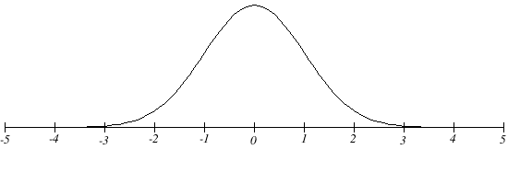
6. Label and shade in the critical region of your sampling distribution.

SOLUTION: Because this is a right-tailed test, and a normal sampling distribution is being used, the critical value is located at The critical (or rejection) region is the area to the right of the critical value (

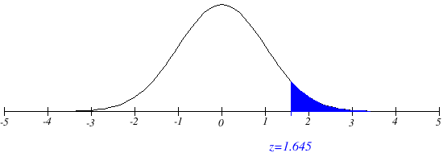
Critical (Rejection) Region

7. Calculate a p-value.

SOLUTION: Using the formula 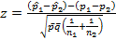 results in:

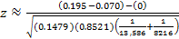 which leads to and finally .

This is an extremely high value for z, resulting in a p-value that is virtually zero (

8. State your decision regarding the null hypothesis.

SOLUTION: Because the p-value is less than α (, the null hypothesis ( is rejected. For those who prefer using a critical (rejection) region method, a z-value of is obviously in the critical (rejection) region of . That also results in rejecting the null hypothesis.

9. Discuss what conclusion you make from the scenario.

SOLUTION: Rejecting the null hypothesis implies that the alternative hypothesis must be accepted at true. Because the original claim was associated with the alternative hypothesis, that claim is now supported. In other words:

There is sufficient evidence, at the 0.05% level of significance, to support the claim that for a specific geographical area in the United States, the age-adjusted rate of prevalence of diabetes in Native Americans is higher than that of their non-Hispanic white counterparts.

10. Briefly comment on what assumptions you make in conducting your test. Do these assumptions appear to be met?

SOLUTION: There are a number of assumptions, or at least some uncertainties, that were made in conducting this test. They include, but are not necessarily limited to, the following:

- Choosing counties that are geographically close minimizes the chance of confounding variables. The purpose here was to try to eliminate factors that may contribute to increased chances of having diabetes. Lack of physical activity is one risk factor for diabetes. Certain areas in the U.S. are less advantageous for outdoor physical activity – especially during the winter months. Choosing counties that are geographically close minimizes that as a confounding variable. Similarly, unhealthy food choices, which can contribute to high blood pressure and a high Body Mass Index, are a risk factor. Availability and popularity of certain types of food will be similar in geographically close regions.
- Using age-adjusted data minimizes the chance of confounding variables. There may be considerable differences in the age structures between the two counties that are being compared. Age-adjustment is a statistical method that allows the comparison of the two counties and removes confounding caused by age. The National Center for Health Statistics provided the information on how age-adjustment was performed for the diabetes data that was collected from the Centers for Disease Control and Prevention’s website.
- Being “Native American” or “non-Hispanic white” may be sort of ambiguous, as far as the data from the U.S. Census Bureau’s website is concerned (and how it pertains to this problem). There is a good chance that many of the people in both counties have a variety of “blood” in their ethnic makeup. Furthermore, neither county had 100% of the people belonging to one ethnic group. Aside from being impossible to find two counties that fit these characteristics, it seems as though the counties are still good representations of what is required to perform the hypothesis test.

ADDITIONAL EXAMPLES
The following examples show two other places in the United States that roughly fit the desired county population criteria. Again, there may be possibilities other than the ones used in this teacher’s guide. Further, the data will likely change throughout the years, so students should cite the locations from which they collected their data. They should also include the year to which their data refers.

Additional Example #1

County in Wisconsin → | Menominee Co. (2010) | Langlade County (2010)
Targeted Ethnicity Population | 3701 (Native American) | 19,267 (White)
Total Population | 4232 ( | 19,977 (
Ethnicity Percent (approx.) | 87.45% Native American | 96.45% White
Diagnosed Diabetes Age-Adjusted Percentage | 11.2% () | 7.3% ()
Number of Successes  () (approx.) | 474 ( | 1458 (

so and (with

All are

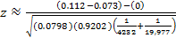 which leads to .

which again, is virtually zero. Or, for critical (rejection) region fans, the z-value of is definitely in the critical (rejection) region of

In either case, the null hypothesis is rejected and the alternative hypothesis is supported.

Additional Example #2

Boroughs in Alaska → | Bethel C.A. (2010) | Denali Borough (2010)
Targeted Ethnicity Population | 14,109 (Native American) | 1637 (White)
Total Population | 17,013 ( | 1826 (
Ethnicity Percent (approx.) | 83% Native American | 90% White
Diagnosed Diabetes Age-Adjusted Percentage | 7.7% () | 6.6% ()
Number of Successes  () (approx.) | 1310 ( | 121 (

so and (with

All are

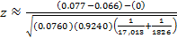 which leads to .

, which is less than (just barely). Or, for critical (rejection) region fans, the z-value of is in the critical (rejection) region of (again, just barely).

In either case, the null hypothesis is rejected and the alternative hypothesis is supported.

MAPS
The following maps show the location of the counties that were used in the three different examples included in this teacher’s guide.

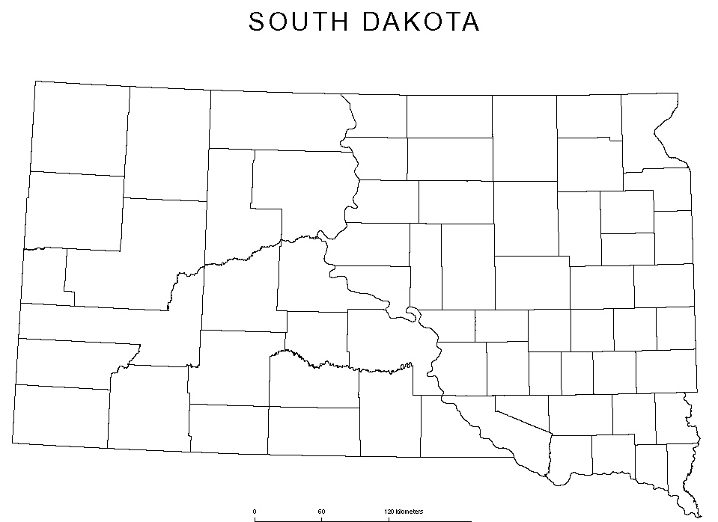
Custer
Shannon

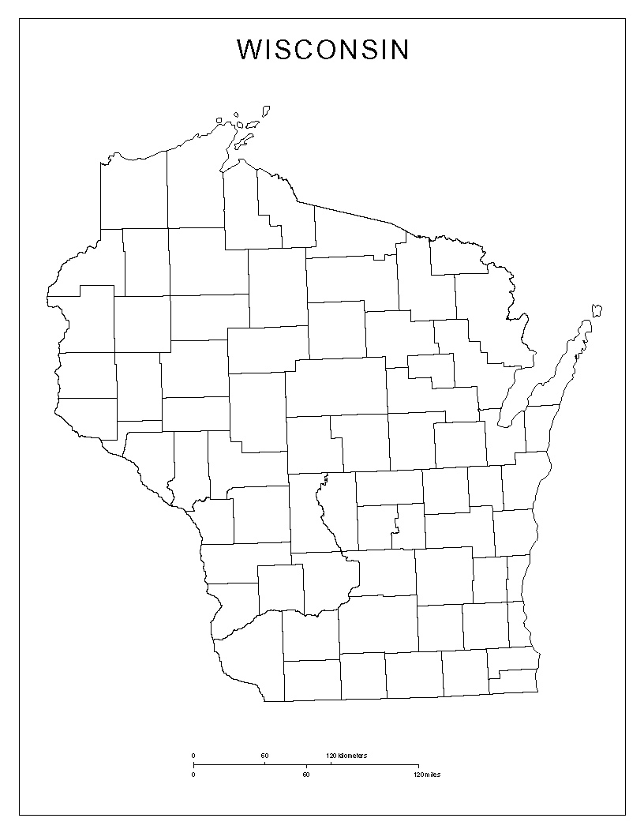
Langlade
Menominee

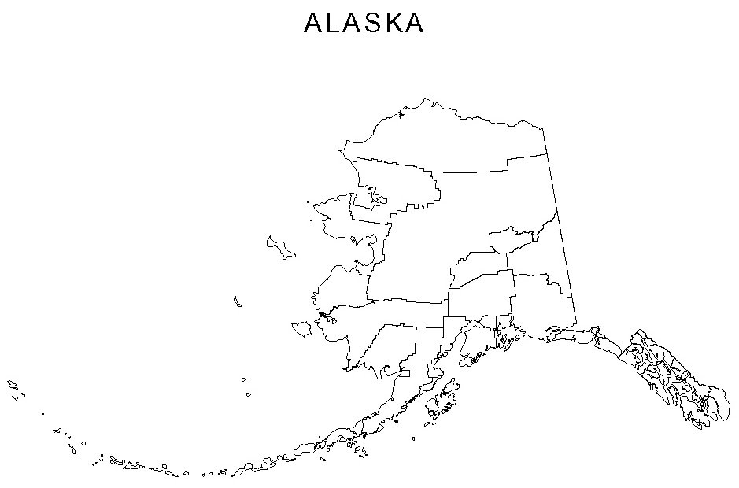
Denali
Bethel

